**Output:**

**Step 1:** Install gPg4win Tool by clicking the link

(https://www.gpg4win.org/thanks-for-download.html)

Click Download

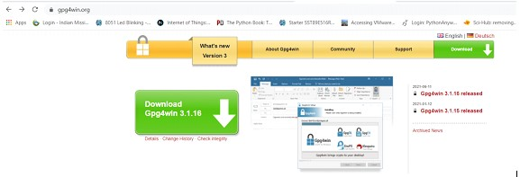

Click on 0 dollar and download

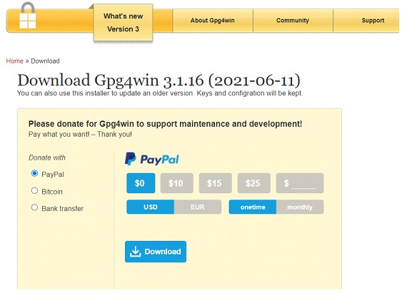

Click ok ------> Next ------> Select GPA and Browser Integration -----> Install -----> Finish **Step**

**2:** Click Kleopatra Software

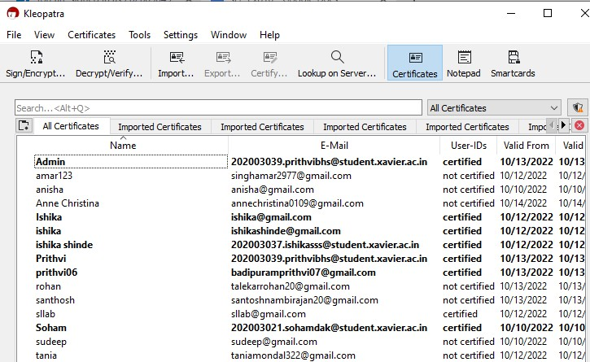

Click on File ------> New Key Pair

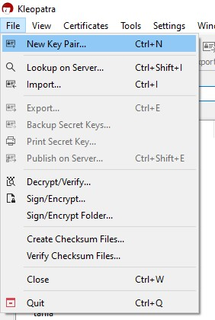

Select Create a OpenPGP Key Pair

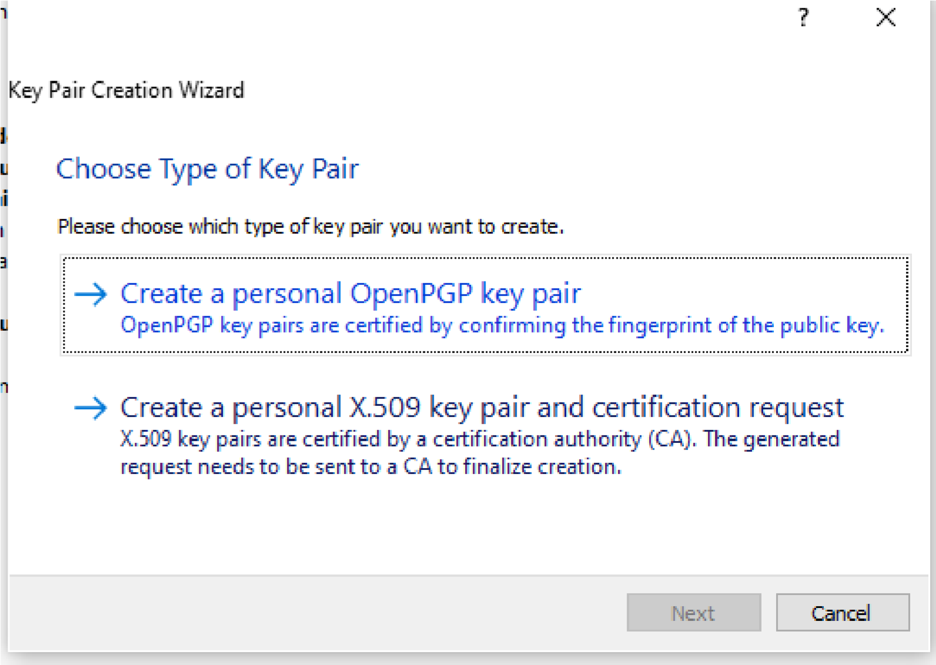

Click Next and give User name “your name”

Mail as “yourname@gamail.com”

Click on Protect the generated key with a passphrase

Select Create

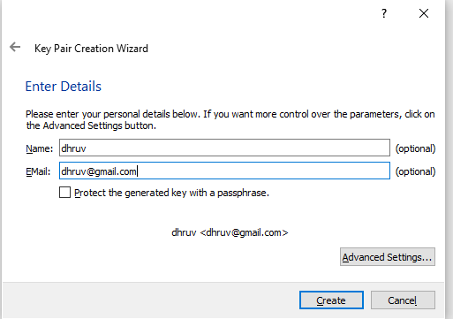

Give the password

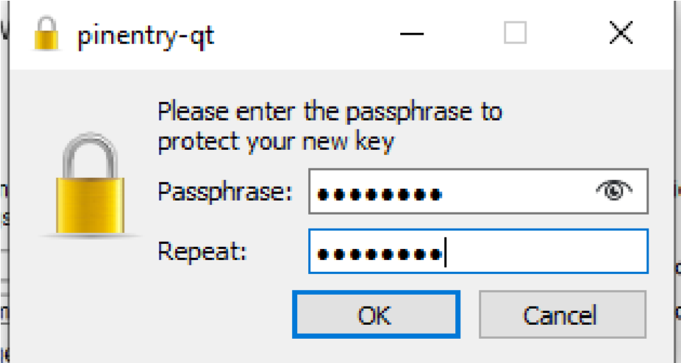

Key pair will be created Successfully

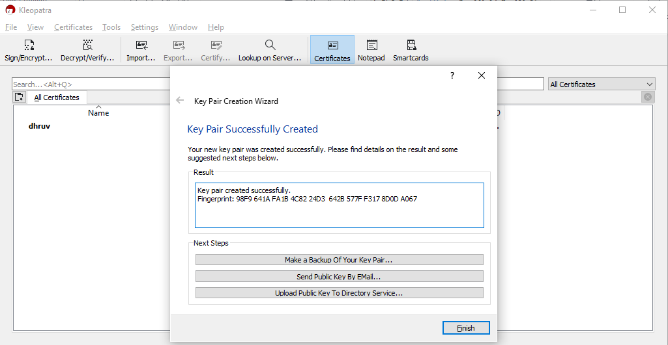

Click finish

**Step 3:** Go to the Kleopatra and right click the name field and click export and save it as public key

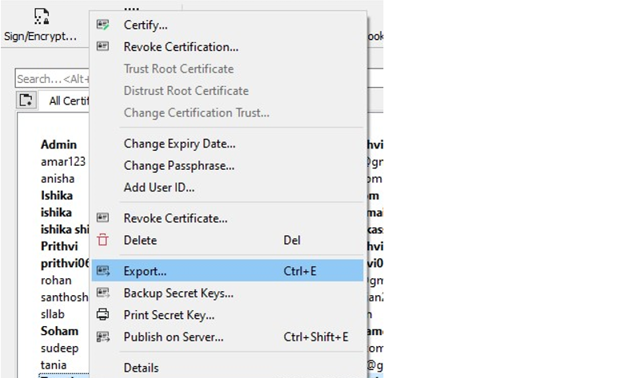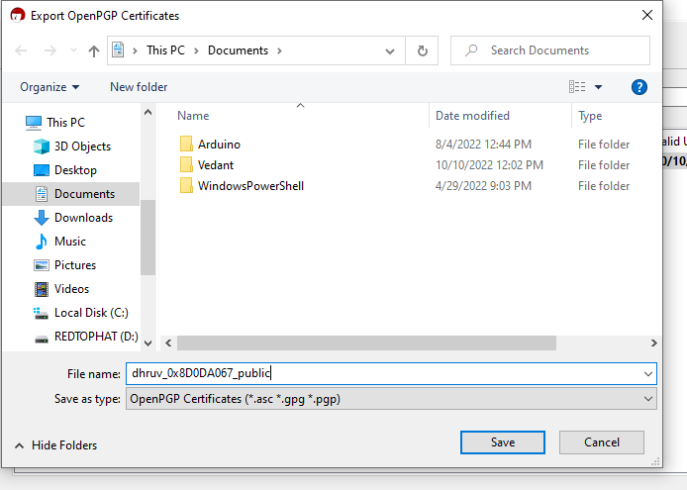

**Step 4:** Go to the Kleopatra and right click the EMAIL field and click backup secret key and

save as a private key

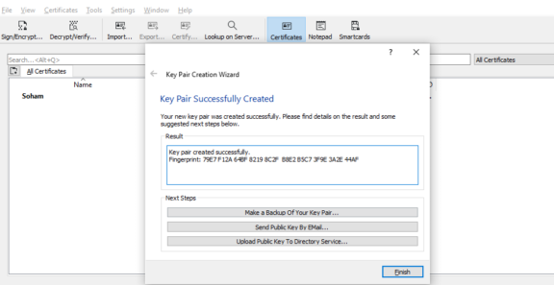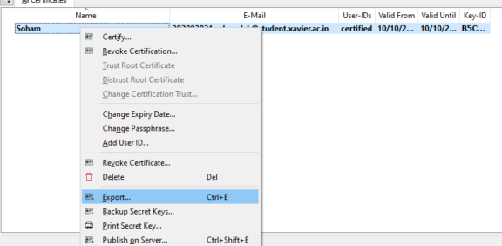

Create a Folder with your name in the network IP \\172.20.210.56 and paste your public key

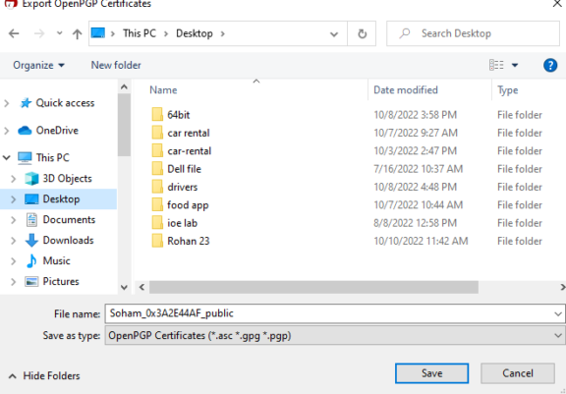

Copy the public key of the user whom you want to send an email in your desktop

Go to the kleopatra software and click import and select the public key of the user

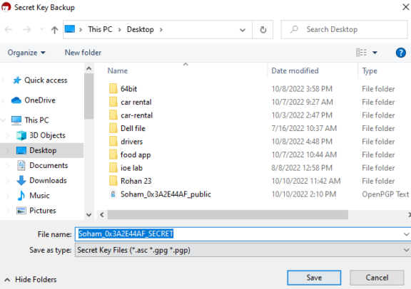

**Step 5:** Click notepad type message and encrypt with the users public key

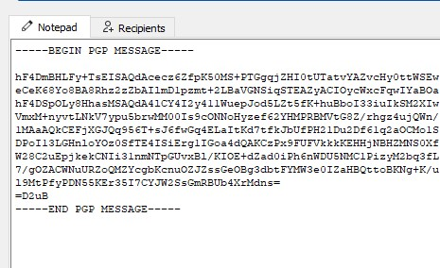

**Step 6:** Do the Same procedure for the Decryption

